**B. Naga Gayathri**  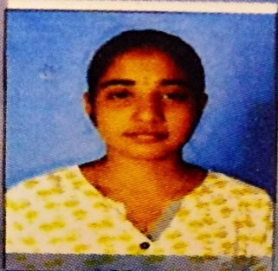

Contact No:8919907824

E-mail : gayathribandlamudi123@gmail.com

Linkedin link: <https://www.linkedin.com/in/gayathri-bandlamudi-07ab57246>

Github link: <https://github.com/gayathri1573>

__________________________________________________________________________________

# Career Objective

To pursue a challenging career and be a part of progressive organization that gives a scope to enhance my knowledge and utilize my skills towards the growth of the organization.

# Academic Credentials

|  |  |  |  |
| --- | --- | --- | --- |
| **Qualifications** | **Institution** | **Passed out year** | **Percentage /**  CGPA |
| B. Tech,  Computer Science  Engineering | Universal College of Engineering and Technology(UCET),  Guntur. | 2024 | 8.2(Till date) |
| Intermediate | Bhashyam junior College,  Guntur. | 2020 | 9.67 |
| SSC | Bhashyam High School,  Guntur. | 2018 | 9.8 |

# Key skills

* Team work
* Leadership
* Initiative
* Adaptability to change
* Prior history of results & Progressive experience

# Technical Skills

* Programming Languages : HTML,JAVA,PYTHON.

**Workshop**

* Attended 5-Day online Workshop on “PYTHON PROGRAMMING” organised by IGNITED MINDS ORGANIZATION ANDHRAPRADESH.
* Attended 7-Day online Bootcamp on “Create Facebook login Using HTML & CSS” organised by Devtown.

# Achievements

* Achieved an certificate on “Python programming(Basic)”in hackerrank
* Microsoft learn student ambassador

# Personal Details

* Mother’s Name : B.sailaja
* Father’s Name : B.SambaSivaRao
* Address : Gundlapallem,Dr-No:4-48

Medikondur(MD)

Guntur,522438

* Date of Birth :15-07-2003.
* Marital status :Single
* Languages Known : English, Telugu.
* Nationality/Religion : Indian/Hindu.

# Declaration

I hereby declare that the information provided above are complete and true to the best of my knowledge and belief.

Signature :

B.Naga Gayathri

Place: Guntur

Date: 07-03-2023